Doc Writer: Haritha Dannamaneni Doc Date: DEC 12, 2014.

Application or System Name
Transaction Profile Automation (BL_ENH_POST_005)
General Overview
Business Requirements:
The registers on the smart meter (KWH, KW and KVARH) will initially be read manually. As part of SAP R4B Release, the registers for KWH and KVARH will be read over the air and the max demand billing determinant will be calculated by the MDM based on the interval values in the external MDM system.
In order to activate the over the air meter reading, the set-up AMI meter needs to be modified. In addition, EDM profile needs to be created and allocated to the correct register so that the SAP billing engine can access the billing determinant calculated by the MDM.
An SAP transaction code will be developed to automate device register modification, profile creation and profile allocation. This will be used to automate profile allocation for miscellaneous cases where profile allocation is not successful from regular processes.

Technical Design:
Program Name: ZBL_TRANSPROFILE_AUTOMATION
T-Code: ZBI_EDM_AUTOMATE
The requirement needs to automate the following functionalities.
- Device modification need to be performed to prepare the AMI meter for over the air reads. For this, the function modules ‘ISU_S_DEVICEMOD_CHANGE' and 'ISU_S_DEVICERATE_CHANGE' are used. Adjust the device register based on values available in table: ZTCC_BILINS_ELEC.
- EDM profile for the max demand will be created using function module

ISU_S_PROFHEAD_CREATE. Other fields for profile header creation would be profile type, PV category and Measurement Unit. The interval length of profile will be based on Interval Length ID at register group of device and that will be 15 minutes.
- The above created profile need to be allocated to installation and to interval register of device. Perform profile allocation for new installation for the new device with the available start date and with the end date 12/31/9999. This will be done by function module 'ISU_S_PROFASS_CHANGE' .Allocate profile to device with profile role – Ext to SAP Consumption Measured – KWH.
- After allocation of profile, to synchronize EDM profile to the MDM a message should be triggered to notify MDM of the profile allocation to a register this functionality is done in the method ZCL_TRANSPROFILE_AUTOMATION=>SYNCHRONIZE_PROFILES.
This method treats each interval for the mass activity eamiprofsync .It first retrieves all the profiles from the interval and then builds application data used by the enterprise service UtilitiesTimeSeriesERPReplicationBulkRequest Out
- De allocates the EDM profile using Function module ‘ISU_O_PROFASS_ACTION’.
- After functionality, application message log will be generated with appropriate messages.

System Diagram
☐ Screen that’s presented to user

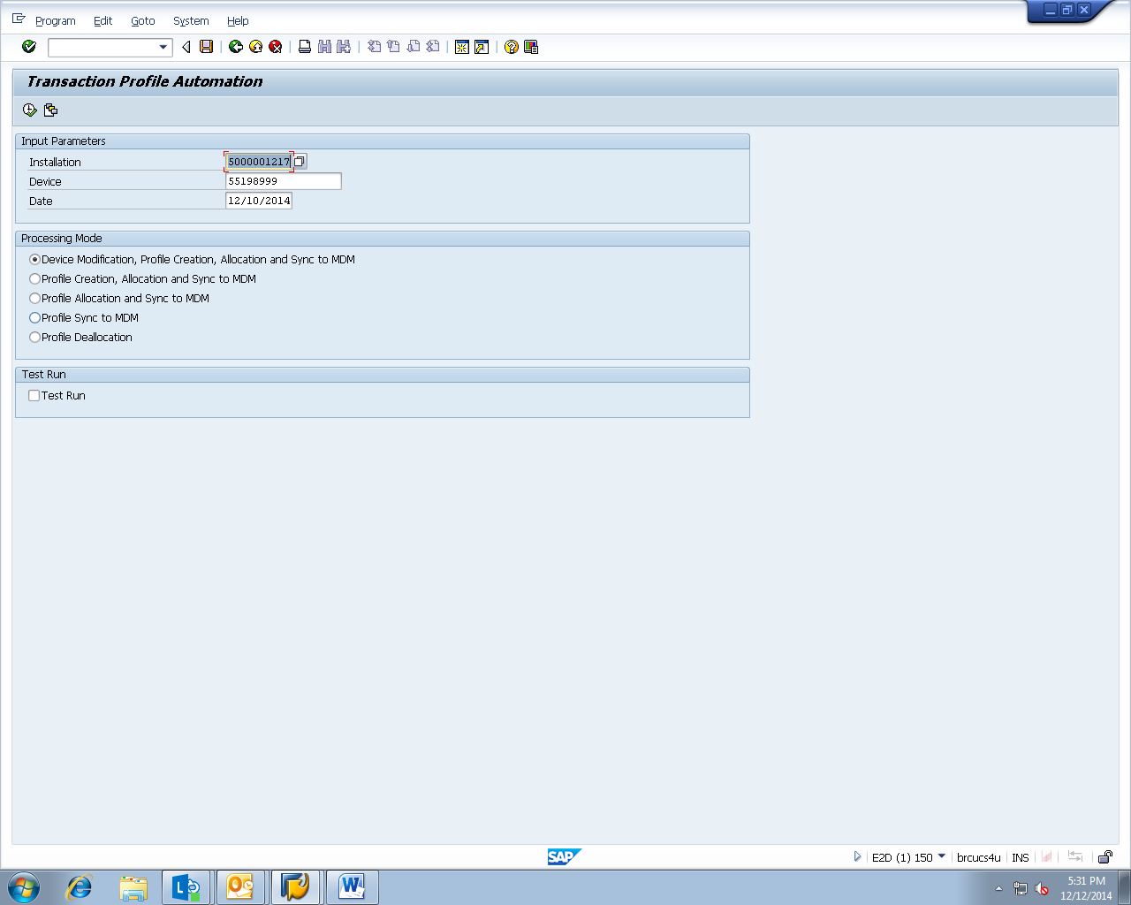

Technical Parts Inventory

-------Name------- | ----Description---- | -----Location----- | ----Environment---
ZBL_TRANSPROFILE_AUTOMATION | Program |  | E2D
ZCL_TRANSPROFILE_AUTOMATION | Class |  | E2D
ZBI_EDM_AUTOMATE | T-Code |  | E2D
ZTCC_BILINS_ELEC | Table |  | E2D

Dependent Parts Inventory
-------Name------- | ----Description--- | -----Location----- | ----Environment---

Security Roles and AD Group Needed to Run App

